YEAR 11 GENERAL HUMAN BIOLOGY

Task 7: Digestion, Diet and Excretion Test

Multiple Choice 20 Marks
Short Answer 25 Marks
Total 45 Marks

- Absorption of digested food occurs largely in the:

(a) stomach.
(b) pancreas.
(c) small intestine.
(d) large intestine.

- Urea is produced in the

- pancreas
- liver
- kidney
- skin

- The three major parts of the kidney from the outermost layer to the innermost layer are the

- medulla,cortex and pelvis
- cortex,pelvis and medulla
- medulla,pelvis and cortex
- cortex,medulla and pelvis

- Elimination is:

- Removing metabolic wastes from the body
- Defecating undigested food
- Urinating
- Sweating

- Incisor teeth are designed for

- chewing
- tearing
- biting
- grinding

- A full set of teeth consists of
- 36 teeth
- 32 teeth
- 28 teeth
- 24 teeth

- The series of muscular contractions that moves food along the digestive tract is called

- periosteum
- peristalsis
- pericardium
- perimysium

- What is the function of the stomach?
- to absorb nutrients
- to absorb water
- to dissolve and digest food
- to produce solid wastes

- Which of these is not a function of the liver?
  - producing bile, a chemical that helps break down fats and oils
  - storing and releasing blood sugars
  - breaking down alcohol and other drugs
  - absorbing nutrients and water from food

- Which of the following is an INCORRECT pairing of “structure” and “function”?

- Large intestines - remove water from undigested food
- Liver receives - nutrients from the small intestine via the blood
- Small intestine - absorbs small food molecules
- Gall bladder - produces digestive enzymes

- The best source of protein from the list below is:

- Orange
- Bread
- Chicken
- Carrot

- The substance that gives urine its yellow colour is:

- urea
- bile
- potassium
- amino acid

- Large proteins are not normally found in the urine because they:

- Are broken down by the kidneys
- Are too large to be filtered by the kidneys
- Are needed by the body for growth and repair
- Do not exist in the blood, only amino acids are present in the blood

- Which of the following organs are generally considered to be excretory:

- Kidney and lungs
- Kidneys, lungs and large intestine
- Kidneys, skin and lungs
- Lungs, large intestine and skin

- The bladder’s main function is to:

- Absorb some vitamins
- Reabsorb water from urine
- Reabsorb salts from urine
- Store urine before it exits the body

- The order in which urea may pass out of the body is:

- artery-kidney-urethra-bladder-ureter
- vein-kidney-ureter-bladder-urethra
- artery-kidney-ureter-bladder-urethra
- vein-kidney-urethra-bladder-ureter

- Blood in the glomerulus is under strong pressure due to:

- Contractions in nearby muscles
- Differences in concentration
- Reabsorption in the nephron
- Blood pressure in the renal artery

- Where are omega-3 and omega-6 fatty acids most likely found?

- Fish
- Chicken
- Coconut oil
- Pork belly

- What percentage of calories in your diet is recommended to come from fat?

- 5%
- 10%
- 15%
- 20%

- Which type of fats are the most beneficial to your body?

- unsaturated
- saturated
- trans
- none of these are beneficial

11.a) Label the parts of the kidney 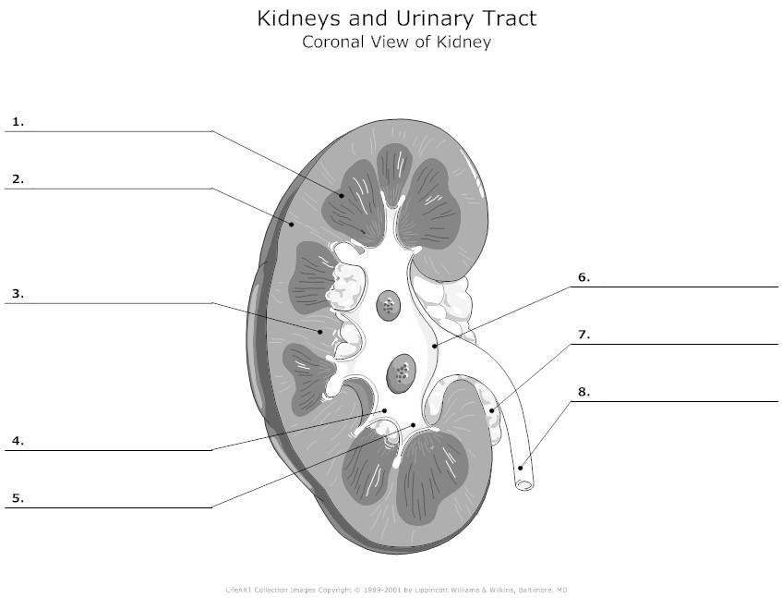
(2 marks)
- _________________________________________

- _________________________________________

6. _____________________________________________

8. ______________________________________________
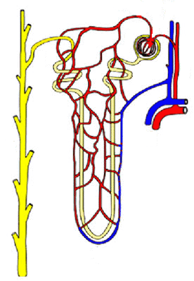
A
B
C
D
E
F
G
I
J
H

b. Label the following components (3 marks)

B |  | E
G |  | H
D |  | I

c. Describe the process of how the nephron filters the blood (4 marks)
______________________________________________________________________________________________________________________________________________________________________________________________________________________________________________________________________________________________________________________

Question 12 refers to the diagram below of the digestive tract.

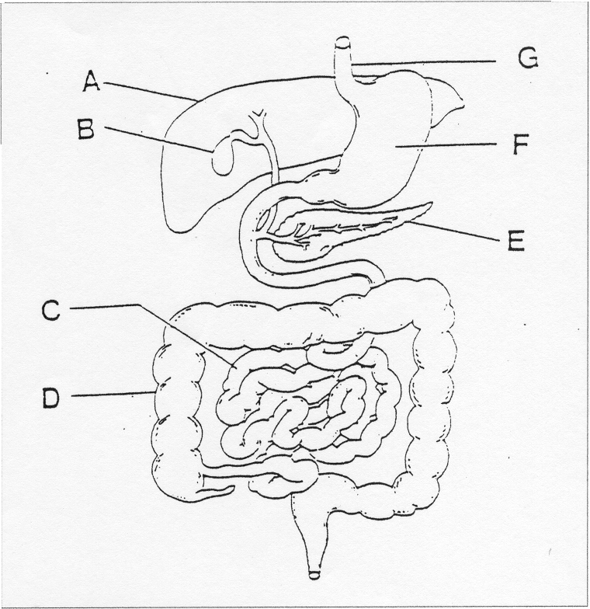

12a Complete the table from the diagram above.
(6 marks)
letter | name | function
A
B
C
D
E
F
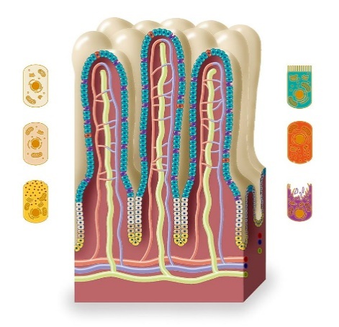
P

(b) (i) Identify P. _______________________________
(1 mark)

(ii) In which region of the digestive tract is P found?
(1 mark) ______________________________________________________________

(iii) Name the major function of P and explain one reasons why it is suited to this function.
(2 marks)
______________________________________________________________________________________________________________________________________________________________________________________________________________________________________________________________________________________________________________________
13. List 4 nutrients the body needs
(2 marks)
______________________________________________________________________________________________________________________________________________________________________________________________________________________________________________________________________________________________________________________

14. Explain why fibre is needed in the body even though it cannot be digested (2 marks)
______________________________________________________________________________________________________________________________________________________________________________________________________________________________________________________________________________________________________________________

15. Describe the difference between mechanical and chemical digestion (2 marks)
______________________________________________________________________________________________________________________________________________________________________________________________________________________________________________________________________________________________________________________

YEAR 11 GENERAL HUMAN BIOLOGY

Task 6:
Digestion, Diet and Excretion Test
SCORES:
MC: /20

SA: /25

Total: /45

TOTAL: /45

_______ %

NAME:_____________________________

TEACHER:__________________________

DATE:______________________________

Section A: Multiple choice (20 Marks)

Cross (X) through the correct answer.
1 | a | b | c | d
2 | a | b | c | d
3 | a | b | c | d
4 | a | b | c | d
5 | a | b | c | d
6 | a | b | c | d
7 | a | b | c | d
8 | a | b | c | d
9 | a | b | c | d
10 | a | b | c | d

11 | a | b | c | d
12 | a | b | c | d
13 | a | b | c | d
14 | a | b | c | d
15 | a | b | c | d
16 | a | b | c | d
17 | a | b | c | d
18 | a | b | c | d
19 | a | b | c | d
20 | a | b | c | d

